Please cite as: Ribot, Jesse. 2019. “Social Causality of our Common Climate Crisis: Toward a Sociodicy for the Anthropocene,” Ch. 2, pp. 35-53 in Tobias Haller, Thomas Breu, Tine De Moor, Christian Rohr and Heinzpeter Znoj (eds.) The Commons in a Glocal World: Global Connections and Local Responses. London: Routledge.

Social Causality of our Common Climate Crisis: Toward a Sociodicy for the Anthropocene

Jesse Ribot, School of International Service at American University, New York University Wagner School, & The Anthropology Program of the City of New York Graduate Center

The full range of causes of climate-related risk are rarely treated by climate impact modelers or analysts. Similarly, when people look at the causes of climate-related crises in commons, they do not look at a full range of causes. Rather, analysts seem to get caught up in proximate causality or in the singular causal link between the hazard (storm or drought) and disaster. While all causes of crisis could never be fully accounted for, in this chapter I reflect on broader ways of approaching cause.

When I write about cause of climate-related crisis I am definitely not writing about the causes of climate change. I am not writing about smokestacks or drivers in New Jersey or Beijing or anything like that. Rather, I mean the causes of the crises themselves. The causes of hunger, famine, dislocation, economic loss; that is, the outcomes that happen when climate trends or events hit the ground. Indeed, there is something happening on the ground that is called vulnerability. By definition, without vulnerability there is no crisis. Crisis is when hazard and vulnerability come together – you need them both (Blaikie 1994). Indeed, if people are not vulnerable, you would not even call these stressors hazards – since vulnerability and hazard are mutually defined. Without vulnerability hazards are demoted to mere nuisance. Vulnerability here is the predisposition, in some way or another, to damage. So, hazard and vulnerability together constitute the climate-risk equation. And climate-related crises do not merely therefore fall from the sky when there is a climate event. They are socially produced via conditions on the ground.

The title of this chapter, Social Causality of our Common Climate Crisis, was inspired by none other than the Pope Francis, who has written the lovely Encyclical On Care for our Common Home (Pope Francis 2015). The Pope uses the term common basically to mean shared. Of course, the boundaries between what is common and what is not common – that is what is private or public – are discursively produced in a global, national and local grammar of political claim making. The ways in which these things we called commons are defined and limited are products of multi-scale social, political and economic struggles. Indeed, the boundaries of the commons are also totally permeable by many higher-scale events – the price of grain or timber, for example, can change the boundaries of commons, a law allowing the export of timber reconfigures those boundaries by transforming the value of and claims on resources.

In the discursive political battle that Pope Francis (2015) is waging, he wants to make sure that we know that most of what ‘is’ ‘should be’ common. He is a common-ist. He is with us. He writes “…the earth is essentially a shared inheritance, whose fruits are meant to benefit everyone. … Hence every ecological approach needs to incorporate a social perspective which takes into account the fundamental rights of the poor and the underprivileged. The principle of the subordination of private property to the universal destination of goods [by which, by the ways, he means social service], and thus the right of everyone to their use, is a golden rule of social conduct and ‘the first principle of the whole ethical and social order’.” Wow. He is evoking the golden rule: “do unto others as you would have them do unto you” (Bible, Matt. 7:12) – implying that our human relations are mediated by this material world we call nature or environment. Indeed, property itself is the relation among people vis-à-vis things, and he seems to be calling for an equitable set of relations – commons.

He argues that social mutuality is needed to guard and sustain humans and to sustain our common home. The world is part of our common heritage and our future, and the world’s wellbeing (that is, environmental sustainability) depends on a necessary social interdependence. In this sense, the Pope is channeling Judith Butler (2009), who talks about security and precarity and the fundamental social interdependence of people at all stages of life. There is no time when your life is not entirely conditioned by its location within society. Basically, the commons are about caring for each other. And because we care for each other we care about nature because we depend on it, not only individually but together as well. Society is fundamentally interconnected; no person or commons exists independent of society and we are all secure to the degree that society makes us secure. This is true in or out of commons.

In short, Pope Francis (2015) and I (Ribot 2014), among others (Sen 1981, Watts 1983; Blaikie et al. 1994, Ribot 1995), locate what are called ‘environmental crises’ in multi-scale political-economic cause. He even goes as far as to explain the developing world, environmental and social crises as being about greed, commodification of people and nature, and the structures of the global financial and economic systems. What I think is amazing is that he does this without citing any political ecology authors. Indeed, he cites the likes of Saint Augustin, he cites former Popes, among other religious figures, and he makes the case beautifully. So, he shows that we can draw in a lot more sources than the gods of our own discipline, and I think we should.

The Pope is providing us with some reflections by which we can chose to ignore or deny God but with which we can create a new humanism; one in which the humans do not dominate nature and nature is not just there to serve humans, but one in which humans must manage and care for nature – because they can and because they need to for their own good. Certainly, elephants and scallops and microbes and rocks (despite what Latour [1988] may intimate), cannot manage humans. We are conscious, have foresight (whether we use it or not), we have the capacity to see the recursive relations between what we do to the world and what that doing does to us. Humanism does not need to mean that humans have rights to nature or that nature is here for us. This is a limited and outdated humanism. Humanism also does not have to maintain its narrow definition of humans – that excluded women, slaves, and non-European races. My humanism, when inclusive as its title implies, is merely the valuing and care by people for people – all people and all people equally.

Today, we live in an economy that produces precarious people, it produces a class that Pierre Bourdieu called the precariat (Bourdieu 1998; also see Standing 2014). These are the vulnerable, these are the people who are pushed over the all-too-low threshold into crisis when expected climate stresses, storms or droughts happen to hit. So damages are caused not by climate or climate change, but rather by pre-existing social, institutional and political-economic marginalization processes, such as undermining rules of collective ownership and access to resources, that cause precarity (Ribot 2014 see also Haller 2015 for a comparable approach). Part of this essay is about how people are pushed into positions close to that threshold. I really want to examine why the causes of vulnerability are rarely treated in policy response, and what social sciences and humanities have to say about that. The reason to explore causality is so that we humans can identify causes and thus care for those who are vulnerable. The failure to do so is part of what makes people vulnerable and thus is a failure of the humanist project.

The new term that we all know (it probably does not seem so new to most people), adaptation, describes public response to climate change risks. We need to adapt to reduce people’s risk in the face of new climate stressors. But to get at how to adapt we need to first understand why people are vulnerable, causality. First you understand why they have a problem and then you do something about it: we need to understand the causes of their vulnerability in order to treat those causes in one way or another.

But the major problem is that the causes of vulnerability are rarely treated within scientific struggles that inform climate adaptation policy. Most climate impact analyses remain obsessed with hazards, they are focused just on the things that are coming out of the sky. Most of those who do look at the vulnerability side of the risk equation, unfortunately focus on proximate variables and do not look into causality very deeply. They are obsessed with things like ‘adaptive capacity’ (whatever that might be) and with some of its proximate determinants; perhaps they even attend to the role of local institutions. They seem to have little interest, however, in looking at the larger context that creates institutions and assets and social protections and the more proximate determinants of vulnerability. Care, however, must go beyond preventing damages at the last moment. It needs to start as far upstream as possible.

The lack of adaptive capacity or of assets, or of social protections, is the product of a larger stratified institutional environment. This formation needs to be explained. Institutions and actions do not just emerge out of some luminiferous ether of Elinor Ostrom’s (2010) policentricity – one that does not address issues of power. Rather, these lacks are about hierarchy and exploitation of institutions related to each other and to the ‘rules of the game’ through unequal material and discursive powers, exercised, as Nancy Peluso and I have emphasised in our work on access (Ribot and Peluso 2003), through law, custom, and convention, but also through stealth, force, coercion, and direct or indirect structural, silent or slow violence. This refers to Rob Nixon’s (2011) concept of slow violence, but one also needs to be reading Silent Violence by Michael Watts (1983), on which Nixon builds his slow violence ideas; both contribute to the question of how we understand and treat Galtung’s (1969) ‘structural violence’.

So, I will briefly illustrate what I mean by causality through a case study. Then I will examine why causality might be so problematic in vulnerability studies by exploring how cause of risk are entangled in social order, and with blame, liability and responsibility, and therefore why they are highly contentious and often avoided. I will then conclude with a note on emancipatory approaches to causality – evoking a humanism that leads us to a productive and just sociodicy.

Multiple causes of climate change and vulnerability in the commons

The climate-risk equation basically states that damages occur at the confluence of climate hazard and vulnerability. Both climate hazard and vulnerability are needed. Without one or the other, you do not have damages – such as hunger, famine, and dislocation. Figure 1 shows the typical model that the IPCC and others have used for years, and it makes sense. You have the hazard, it comes along, it is filtered through some static figments of society (assets, capacities, sensitivity, etc.) and you have a list of outcomes (reduced wellbeing, etc.). Among these static figments is vulnerability, which is defined in the 4th assessment report of the IPCC (4th IPCC Report; Appendix II:89) as:

…the degree to which a system is susceptible to, and unable to cope with, adverse effects of climate change, including climate variability and extremes. Vulnerability is a function of the character, magnitude, and rate of climate change and variation to which a system is exposed, its sensitivity, and its adaptive capacity.

But are the outcomes outlined above really products of a climate hazard and the lack of adaptive capacity? No, they cannot be reduced to this. They are an outcome of much more.

Figure 1: Hazards Model 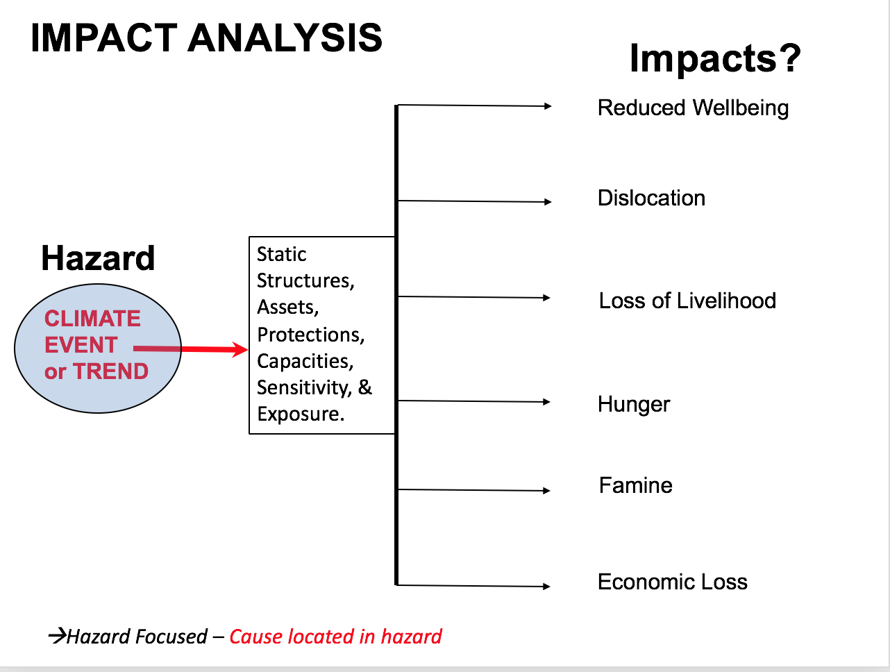

In my own work, I invert the equation – following Sen (1981). Rather than looking at the multiple outcomes of some single event, I look at the multiple causes of a single outcome, because climate events and trends tend to be one set of stressors amongst a whole host of variables that we must understand (Ribot 1995;2014) (see Figure 2). My representation starts with entitlement failures (a la Sen 1981) and explores why there is a lack of assets and a lack of social protections that lead to problems of hunger and famine. You take one value and you find out why it got lost; one damage and explain how it happened. In other words, it is a case study approach. Sen (1984;1987;1999) has a secondary link from capacity and democracy back to capabilities to the shaping of assets and social protection. But, like any good economist, Sen takes assets and lack of social protection to be initial conditions. He does not ask where these ‘initial’ conditions come from, other than saying that they are influenced by democracy, which he defines very broadly as voice and established political processes.

Figure 2: Vulnerability Model 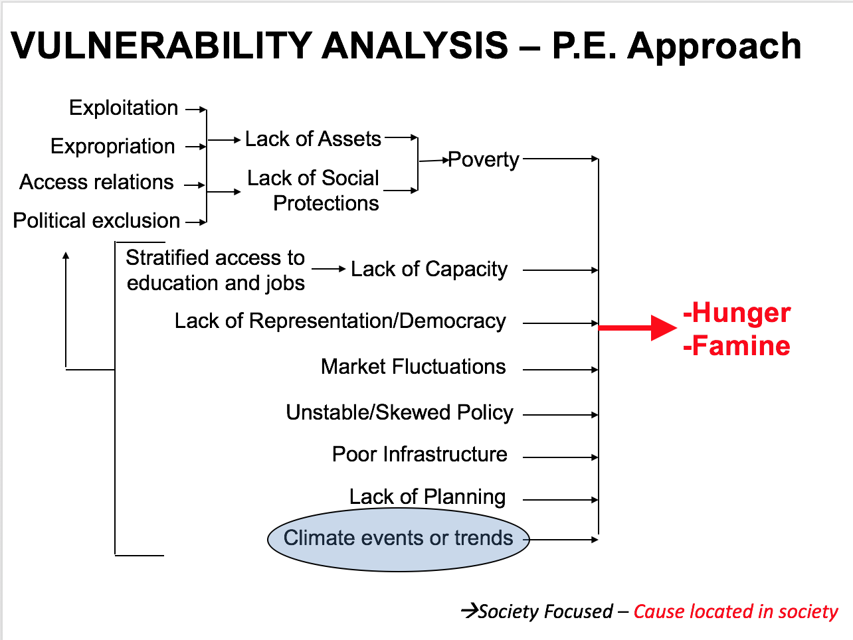

In a political-economic approach, however, you need to go a little further and ask ‘assets’, ‘lack of social protection’, where do they come from? They come from exploitation, expropriation, unequal access relations, political exclusions, that themselves are related to other things happening in other parts of society that have to do with the lack of so-called ‘capacity’ and stratified access to education, lack of representation and democracy. These feed into shaping the broader political economy that shapes one’s assets and social protections. Sen calls those assets and protections ‘entitlements’, and a failure of the entitlements is what leads to hunger, famine and other such crises. Climate in this framing is not at the centre of the universe, but it plays its role. Climate is one of several triggering variables or stressors launching crisis but not the main ‘cause’. Indeed, climate has its role in the causal chain. Yet, climate could not produce damages if the other causal chains behind each factor of vulnerability – such as enclosures or the breakdown of common property regimes – were not already at work.

I will use a case I know well to illustrate this. Dr. Papa Faye – a Senegalese social anthropologist/geographer – and I have been working together in Senegal since 2003. This collaboration, along with a tragedy on April 19, 2015, motivated our current research. That day a boat sank off of Libya, carrying 728 migrants, most of them from Sub-Saharan Africa. There were only 28 survivors, 24 bodies recovered, and the rest, as their parents said in interviews, are at the “bottom of the sea.” These families did not know where their children were. The newspapers call the Sahelian migrants ‘climate refugees’ or ‘climate migrants’ (Foote 2016; Friedman 2016). What nonsense! Refugees are, first of all, defined by law as people running away from oppression or abuse by their governments. Climate is not their government. So, the term refugee does not apply.

A 2017 National Geographic episode, “Out of Africa,” Thomas Friedman, went to Senegal, interviewed people and basically presents the narrative that out-migration is climate driven. Nonsense. Nobody who lives and works in rural Senegal – unless they work for government, a development agency or an NGO – will tell you that their biggest problem is climate or climate change. That narrative is hard to stomach, because when you get out there and you do that place-based analytic of why and how people have access to the resources and income that they need to eat, to produce, to reproduce, to invest in their own households, you will see that they are producing a lot but keeping almost nothing. Any good analysis of why they are vulnerable (that is, why they lack assets, income and social security), has to explain the core of the problem; it has to explain why they have nothing or feel precarious; it has to explain why they have no surplus to buffer themselves against expected, though unpredictable, periodic stressors.

The case I will discuss is in West Africa in the Tambacounda Region of Senegal. It is a dryland millet, peanut, cotton and corn farming area. There are some woodcutters, and the forests do not look very rich, but they are lucrative, and people make considerable income from them. It is a case like Nancy Peluso (1992) has said, of ‘rich forests and poor people’. It is a case of low prices for farm products, expensive inputs and costly credit. It is a case of a commons, the market (not the forest itself), to which farmers who try to supplement their income from woodcutting do not have access. Why?

Crises have histories
The crisis in Tambacounda goes back a long way. It goes back to different moments where West Africa was embedded in different social relations like the slave trade and colonialism (Franke and Chasin 1980; Watts 1983). More recently we see an annual hungry season which is as deep as many years during last 30. We see out migration, including the many from Tambacounda who perished on April 2015. They left for Europe but died at sea. Indeed, more are dying in the desert than die in the Medeterranian (Danish Refugee Council 2016: 2). Youth who depart are aware of some of these dagers, yet they go.

Peasants in Tamba are poor and are vulnerable to hunger and dislocation; indeed they are in a continuous crisis. It is not only a crisis of dislocation or hunger, but the anxiety leading up to that crisis, the insecurity is in itself damaging. These people cannot sleep at night thinking about the fact that they are not going to be able to feed their children (Ribot, Faye and Turner forthcoming [2019]). Anxiety in Tambacounda was at a level that I had not seen. The pain of anxiety is visible and itself needs to be considered a damage of vulnerability – i.e. vulnerability is damaging even if acute crisis does not arrive; even if it does not lead to the hunger, famine, dislocation or emigraiton that we are focusing on.

So the rural economy has many elements: farming peanuts, millet, cotton, corn and rice, or herding, labouring in the cities, hunting, selling timber, selling honey, and charcoal production. Each is lucrative, however none are profitable for forest villagers. There are commons and there are private sector opportunities, but farmers find themselves excluded from profits. Here I am going to look at charcoal production. Charcoal provides a case study of why people do not profit – from forests or markets. It is basically an access analysis that Faye and I have done several times over different periods, starting in the late 1980s, and we have repeated it to see trends and patterns. But, a similar phenomenon is found in all sectors: most producers are wratcheted down to subsistence level or below – different mechanisms in each sector, but all to the same effect of enriching a small elite (usually urban) while leaving the peasants destitute.

The actors in Senegal’s charcoal market include forest villagers, migrant woodcutters (some locals are beginning to work in there), urban merchants, wholesalers, and retailers. When you calculate the profits (a function of margins, expenses and market shares) at each node in the market, it becomes clear very quickly who is getting rich, and it is not the rural people. Figure 3 is a font-scaled distribution of profit along the charcoal commodity chain: the font corresponding to the percentage of profit which goes to each class is applied to that group (see Figure 3). So, 54% of the profit (gross income minus the costs for the ensemble of actors at that level in the market) is assigned a 54 point font. What you see is that that the 54% of the whole market’s profit is divided among 160 merchants, whereas the 16% of the total market profit profit is divided among 11,000 woodcutters. This last 16% sliver is the commons part of the pie. In short, the merchants are wealthy, while the woodcutters live at subsistence level.

Figure 3: 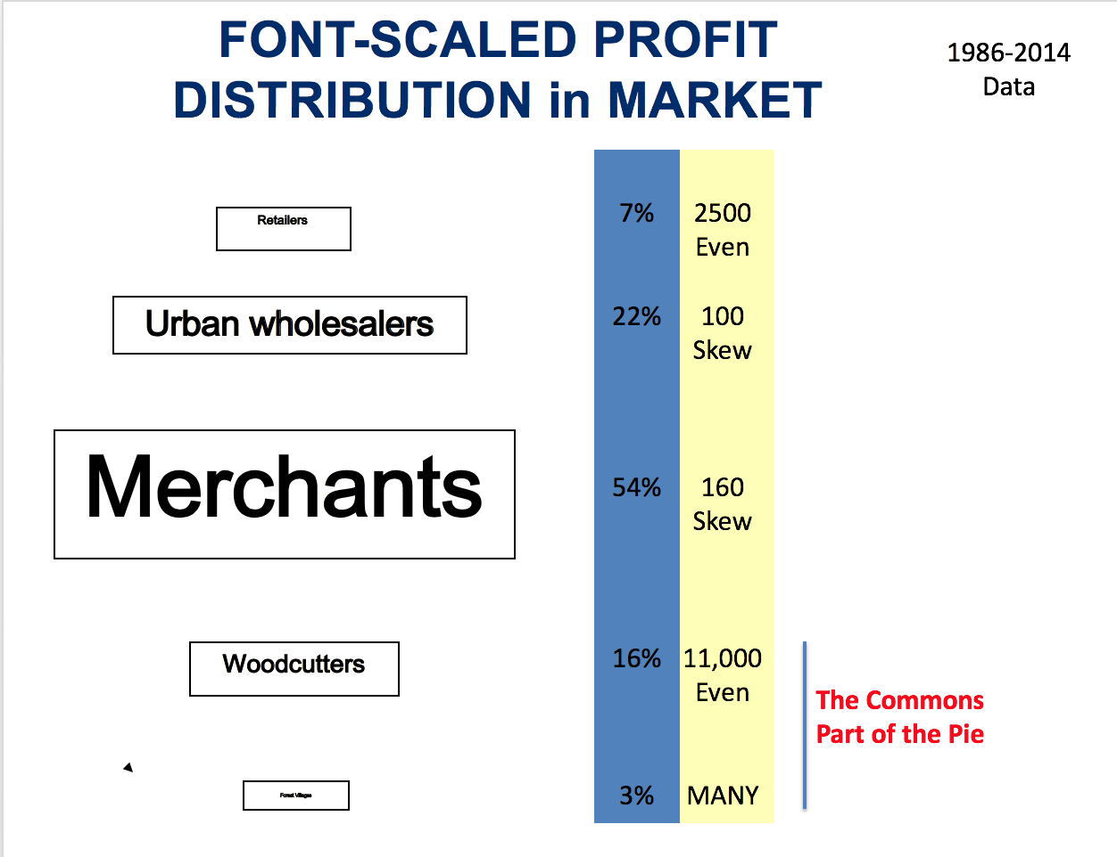

Basically, what you see, using some fairly rough figures (over time this distribution has evolved, although the overall pattern maintains) is that a merchant makes in a few days what a woodcutter makes in a year. I would estimate that today the biggest merchant is making over a million US dollars per year. But since I do not have the exact figures for the recent incomes, earlier ones, 30 years ago, made even as much as 500,000 USD (Ribot 1998). We explain this pattern of distribution by analysing its components. Basically, you go to each group and you ask: “how do these people maintain the share of the market that they have, the price that they get, and the cost of their inputs. How do they control it, can they?” And you begin to find out very quickly that their control over these things is embedded in a very complex policy-structured social environment (see Ribot 1998; Faye and Ribot 2017; Larson and Ribot 2008).

But to make a very brief caricature of this, we can, of course, say that exchange always has all kinds of ‘regulations’ – controls over access to resources, labor, markets, political arenas (a la Ribot and Peluso 2003) – these are what make markets and shape distributions. Markets are not free, they do not exist without some kind of regulation, at the very minimum a provision of currency. In the charcoal market there are licences and quotas (relabeled ‘contracts’ in recent neoliberally tainted years), determined by the forest service, and then the regional forest service offices allocate them to merchants who have the licences and pay taxes (municipal and forestry). With taxes paid, they can then get transport permits. The producers, who have to get producer ID cards and production permits from the merchants, who have the quotas or ‘contracts’ and the licences, have relations with and get these papers from the foresters. You also have under the Ministry of Interior, an elected Regional Council and an elected Rural Council, who formally have powers since 1998 over the allocation of rights to forest, but that power never came to be in their hands, as I will show later (Faye 2017; Ece 2016). So, there are management plans imposed by the forest service, elected rural councils with rights to sign off on these plans (rights they are denied by dint of being forced to sign), and there are fines and confiscations for those who do not obey the array of regulations in place.

So, you have a system that is embedded in policy, but of course it is also embedded in social relations. Identity and other social relations mediated by all kinds of institutions, historical ones like nobility and captivity that relate merchants to woodcutters, who migrated to Senegal when the French attacked the Fulbe aristocracy of Upland Guinea in 1906 and when Sékou Touré attacked them in the 50s. Or the relations between the religious brotherhoods and the merchants that end up eking out quotas and permits and influence who gets to sit on the regional and rural councils through their relations with political parties as well.

So, a market is not outside of its broader context. International agencies and large NGOs put the next layers on – via their projects. The projects, such as those of USAID and the World Bank, often say that government is ‘bad bad bad bad’. They go in to the area and they create the ‘Business Model’ and rename the quota the contract – despite that the contract is exactly the same thing as the quota: it says who can produce, the amount they get to produce and when and where. So, development, conservation and adaptation become the priority of projects, despite that goals were supposed to be set by the rural council. Management plans and “participation” are instituted with new institutions like committees, NGOs and chiefs and “participatory projects and processes” because those are the ones who the projects believe should be making decisions. The rural council was elected and has the legal right to make these decisions, but the councils are what Papa Faye calls “de-recognised” by these outside institutions (Faye 2014). Their powers are allocated to committees and thus they are disempowered and lose recognition.

There are many laws and regulations and programmes and projects to, ostensibly, help increase rural incomes. Participatory forestry Code of 1993 that became what I call ‘participatory corvée’ (Ribot 1996), forced labour – and that is what ‘participatory’ often is (see also Cooke and Kothari 2001, Galvin and Haller 2008). Democratic decentralisation that empowered the rural council but gets taken back; contracts that I have already described were created to replace the quota; all to “empower” local people, but they do not end up doing this. Forestry projects, USAID and the World Bank are very well meaning, but they did not end up doing what they claim.

Basically, with these projects, a lot of things unfolded in between design and implementation that had to do with the actual in-place negotiations amongst various hierarchies and following different laws, customs and conventions concerning who gets what, when and how. For whom these programs would be lucrative is already pre-determined by the previous generation of patterns. They are ethnically defined, party defined, they are defined by religious brotherhoods in various ways, but they are also defined by gender, by place of origin and so on. So, each policy has a micro-politics that I cannot fully develop here, yet of which I have mentioned a few elements. These are important, and we need to understand them. They are often shrouded in interesting discursive sorts of mechanisms. Each local income improvement was in this case supported and fought for by the elected local government. By the way USAID fought to support the local government in many of these instances, and in certain instances helped local government to help rural people; but again, ultimately failed for a variety of reasons.

As an example of the kind of discourse, here is a tongue-in-cheek caricature of a forester speaking to, or lecturing, villagers from a book I wrote (Ribot 2017; also see Ribot 1997):

“Look, here in the rulebook – which you must obey,
you have rights to the things that we don’t take away.

But we can’t take the wood without taking the trees,
so you’ll have to make do, with the stumps, and some seeds.

You can grow woodlots, eucalyptus or pine,
we’ll help you to manage them, through incentives or fines.

If you listen, look, learn, and do as we say,
even democratisation will be on its way.

We must protect forests from people like you,
so that people with business will have business to do.”
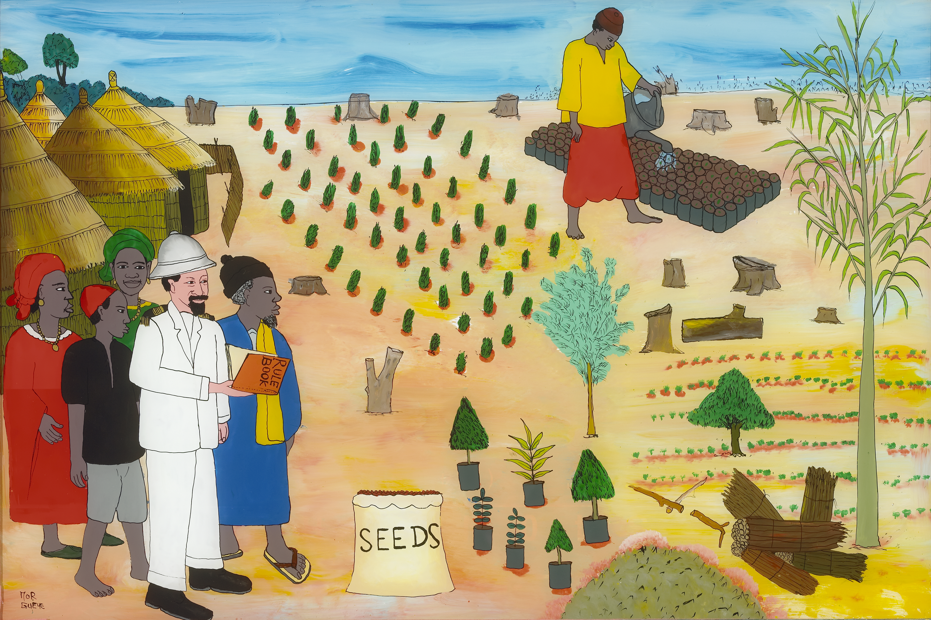

Source: Ribot 2017 – Painting by the Senegalese reverse-glass painter Mor Gueye.

That is the kind of language that forest villagers have heard over and over again while being ‘empowered’; and they are sick of it. They know it and they hear it, and they even know how to play projects – by just saying ‘yes’ back (a la Scott 1976). But all the good intentions of projects do not take away this kind of discursive deceit – a deceit that project staff and forests may not even be aware of since they believe their own contorted narratives.

The Precarity of Sector by Sector Exploitation Does not Fall from the Sky
This is a quick sketch of part of what is going on – in domains of law, social relations and project interventions – that contribute to the production of the inequalities we see in the charcoal sector (see also Ribot 1996; Faye, Haller and Ribot 2018; Ribot and Faye 2017). We see these skewed distributions that I have described, however, not only in charcoal but in all of the sectors. In the cotton sector, the international price goes up but the producer price stays flat. For good reasons, producer prices are fixed by intermediaries and corporations in cahoots with government and so on. Forest villagers remain at subsistence with no hope and no profit – regardless of international prices. They are also strapped with debt from equipment and input advances. Out-migration is one option; but as you can see, these migrants are not climate migrants – they are refugees of a system that excludes them from a livable income. (Ribot, Faye and Turner 2019 forthcoming.)

Virtually no Senegalese farmer will tell you that they suffer due to the climate, nature is not their problem. Farmers knowingly place responsibility in taxes, permits, licences, fixed prices, failed representation, market access, access to government services and so on. These are what need fixing and adapting. Elected local governments have tried to improve benefit retention but again, they have been thwarted by line ministries, which are the single most important obstacle to any decent democratic decentralisation effort worldwide. They hang onto the funds they should have transferred to local authorities. It is time to ‘adapt’ the line ministries: take their money away and transfer it to local governments.

I have described some of the major causes of vulnerability and resulting ‘climate-related’ crises. Why, however, are they so difficult to identify and treat? Why don’t we engage in causal analysis and treat the causes?

On causes of vulnerabilities: Weber, Douglas, Rose and Risk under a Changing Sky
The second part of this paper touches on the causes of vulnerability as they have been treated by social sciences historically. The case I presented shows that suffering and crises that climate modelers usually attribute to rainfall and drought cannot be explained outside of social and political-economic relations. Most serious social scientists know this – it is not a mystery. But why can’t this kind of explanation even enter into our understanding of causes of the climate-related crises that the climate change community is ostensibly so worried about. Why, for example, in the IPCC 5th assessment report, has vulnerability been reduced to a focus on indicators of who is vulnerable rather than an analysis of why (based on my search of the word ‘vulnerability’ and its use in the report). We need to know why people have become and remain vulnerable if we are going to change things and fix the problem.

Analysts seem to want to know who will be damaged and how much, but attention to cause receives a lot of resistance – or ends at ‘adaptive capacity’ (see Ribot 2011). Why is the question of ‘why’ so complicated? Why are social sciences that attend to political and economic structure and causality written off in climate science and adaptation studies, as well as being underutilised in common-property work. I suggest that we avoid explaining the causes of risk because causality is linked to two major issues: one is the issue of responsibility, blame and liability, and the other is the maintenance of authority. I think that vulnerability is difficult because risk is actually a very special category of social interaction and meaning. It is not just any phenomenon, vulnerability is distinct. It has very special characteristics that make it difficult to talk about and respond to.

The British sociologist Iain Wilkinson (2010) argues, as do many sociologists from Max Weber on, that risk plays key roles in organising society, and in doing so produces very political divide that make risk so important and so contentious in social debate. They all postulate – and this is interesting – that risk is different from other disputed and political ideas. Rooted in Wilkinson’s reading of risk sociology, I will briefly go through three key theories and what they have to say about this. I am going to start with Max Weber on risk and enlightenment and then say a bit on Ulrich Beck, Mary Douglas and Nicholas Rose.

According to Weber, pain and suffering are the foundations of atheism (Wilkinson 2010). Religious leaders spent a great deal of their energies on the practice of theodicy, that is, the practice of explaining why there is pain and suffering if God is so good. When rationalisation of suffering in religious systems failed, people moved toward secular understanding. Theodicy was an important branch of theology, since it helped to retain believers. It also secured the authority of the church. As Wilkinson (2010:28) notes, “…all human cultures are faced with the task of dealing with what appears to be an excessive amount of suffering in the world. In all times and all places people struggled to find solutions to this pain and suffering and are compelled to work at making sense of this experience in terms of the overall meaning of their lives.” And, of course, I would add, they must also explain in order to cope with or reduce suffering, or even just to sense that they have some control over their world and lives.

From authority, people expect protection or explanation, they have a kind of moral-economy relation with those who govern (Scott 1976). The rationalisation, and thus containing and explaining, of suffering is a foundational element of social organisation and of any governing system. Suffering is the enemy, God (or, post-enlightenment, government) should protect us. The authority of recent governments rests on their ability to rationalise and protect (look at the loss of legitimacy of the Bush regime after its failure to even appear to protect people during and after Katrina and the showy efforts of warning that US state and federal authorities now make before any storm). For Weber, the link between rationalisation, cause and blame are key elements in the study of risk, and they are key elements in how risk is understood. In short, when in need of release from suffering, as Wilkinson argues in his reading of Weber, people devote themselves to rationalisation. They explain cause and thus attribute blame.

A little side observation here, which Weber does not make, in the course of response, responses are guided by different theoretical and philosophical stances, that is different rationalisations that inform notions of causality. Theory and historiography matter then in understandings of causality. Hence, they too become contested by those who stand to gain or lose based on explanations. So, explanation itself becomes contested terrain. This is for me a central pillar of a politics of knowledge (knowledge of cause) – and I would argue that it is central to any politics of risk; including the politics of including the causes of risk within scientific models of climate impact.

Wilkinson (2010:29) explains, getting back to Weber, that there is an ‘imperative of consistency’, a kind of compulsion, that forces people to make sense of the world in terms of their cultural outlooks. They try to maintain the status quo. But the changing world also forces them to change cultural outlooks in order to maintain consistency with the world. This is basically Weber’s theory of social change. In a sense, explaining of disaster, where disasters represent changes in people’s worlds, is, for Weber, a driver of cultural change; thus, explanation threatens the status quo. We, that is climate risk vulnerability analysts, note this when we analyse causality of vulnerability and find ourselves up against resistance in multiple camps. In short, Weber argues that theodicy (pre-enlightenment) and rationalising of risk (post) are foundation of social change.

Then comes Ulrich Beck (again see Wilkinson 2010 for his fabulous summary). Beck, with his ‘risk society’ approach, makes another set of arguments placing risk at the center of social organization. He asserts that risk perception, as risks have become global and potentially destructive across any human borders, has a political-mobilization force. He believes that pending global catastrophe pushes people to come together and organize across national boundaries. The result of his reflections is a utopian cosmopolitanism that enables NGOs and other groups to reshape global institutions. People becoming more ‘world-risk conscious’ will organize to save themselves. This wishful thinking has many shortcomings, but it does place risk at the center of social and political organization and change and launches numerous debates on risk and society.

Next are Mary Douglas’s ideas of risk, danger and society. Again drawing on Wilkinson (2010), for Mary Douglas, as a cultural anthropologist, the reality of risk that people fear is not the issue. Reality does not matter. She only focuses on the social function of risk. She argues that when social bonds that hold people together are weak, people tend to become obsessed with disaster. Perhaps the weak bonds of late capitalism are a condition of our own sense of risk in the fragmented societies of late capitalism. She argues that preoccupation with disaster plays a positive role for society. By finding a common threat, communities come together and organise around common social objectives. They protect their group from harm. This may seem self-evident, but simultaneously, as part of groups’ survivals, comes the search for explanation and blame, which helps further consolidate the group by defining insiders and outsiders. It defines and identifies those who belong and creates boundaries that define the community. It also defines the other. Certainly, a point common-property theorists might want to take up, when it comes to boundary-making.

In agreement with Weber, Mary Douglas sees discourses of risk as having taken the place of discourse of theodicy. The language of ‘sin’ had been supplanted by language of ’risk’, both being languages of blame. Where people used to talk about being ‘sinned against’, they now speak of being ‘at risk’. “…The language of sin appeals to the authority of priests…, risk appeals to the authority of science and modern rationality” (Wilkinson 2010:49-50). Populations defined as ‘at risk’ carry the moral stigma of sinners since they are burdens on society. Douglas would argue that in secular consciousness, nature has replaced God. In so doing, people can rationalise crises through probabilities and attribute causality (and thus blame) to the vagaries of nature. They can sidestep blame – since ‘nature’ cannot be guilty (unless you want to attribute agency to it as does Bruno Latour – a very problematic proposition [see Braunstein 2018 on the moral philosophy of humanism]).

This brings us to an interesting question in the present. What happens in the current era of anthropogenic nature, when nature is caused by human action, and no longer a mysterious random blame-free force? What happens when storms, floods, droughts are blamed on industry and SUV drivers in the North? Then a new structuring of insiders and outsiders forms, and responsibility and blame are re-arranged on a global scale. A new causality behind nature itself suddenly erases nature as a sink for blame. When God is dead, and nature can no longer replace God because it has become a social product, there is no longer room for non-human explanation of the experience of suffering. Society is turned back on itself. God and nature are dead, God dies with enlightenment, and nature, as sink for blame and perhaps as an entity, dies with the Anthropocene – at least for those who can cope with social explanation. The Anthropocene infuses social explanation into the forces we usually call nature. Perhaps we should call it the Sociocene. Welcome to the Sociocene (that’s the scene I like to be in)!

With this death of nature, the above social theories would imply that we are entering a transformative moment of social re-organisation. The first scary question is who will the priests be? Political scientists? Social scientists? I do not think so. But in any case, Mary Douglas (1996) also talks of the public assessment of risk, as being embedded more in the trust of sources of information than in what is or is not truth, making it inherently political. Here, trust, authority and credibility become another foundation of the contentious politics of risk. Clearly, we are seeing the reconfiguration of credibility in the Trump era – and it is playing on denial of all kinds of blame, liability and responsibility. It is creating dueling causal arguments along with dueling social spheres – each with its different boundary construction.

I cannot develop this line of thought here, it implies, however, that with a proliferation of authorities (related to God, nature and society), since none seem to fully die, problems of trust will deepen and so will associated social fragmentations. Douglas casts the politics of knowledge as one of trust, I would cast it as one of interest as well (being somewhat of a materialist). Of course, the two are intertwined: we trust those, whose positions resonate with our interests. This explains partly why God keeps rearing up and why nature seems to be such a comforting sink for blame. When we displace blame from state and society onto God and nature, we protect the trustworthiness of existing state and scientific authorities, since nobody can trust or mistrust a transcendental God or an authorless nature. This is precisely why they are preferred over social explanations, which usually indicate blame and undermine these very same authorities. This is why we need a sociodicy of the anthropocene – a sociodicy being an attempt to explain pain and suffering in human terms and through human/social cause. Those causes can be found when looked for.

We need a little note here about causality, responsibility and anthropogenic climate change – for climate change makes climate un-natural. As human agency now arcs across the sky, why is it that many government institutions are accepting explanations that acknowledge anthropogenic climate change – making it possible to place blame on the industrial world? The acknowledgement of anthropogenic climate change is still, of course, incomplete – the Trumps of the world deny it – but many within various governments around the world accept the link between human action and climate stress. It seems that part of what makes this possible is that climate-change causality remains so abstract and diffuse that it blames everyone and thus no one. Industries spread worldwide are blamed, individual car drivers are indicated, tropical forests are brought in, fuelwood burning is brought in, India and China and Brazil’s development are brought in to the causes – thus including and blaming both the industrial and developing world. Cause is being constructed as common, a commons. It is being constructed as an effect of being human (anthropos) rather than the outcome of specific social structures or of specific actors in specific places whose profligate waste of resources and energy are undermining the opportunities and potentials of others whose access is restricted. Responsibility in this representation remains diffuse – despite even the acknowledgement of responsibility (limited responsibility) constructed under the notion of ‘additionality’ in UN conventions on climate change (see Ribot 2014).

Lastly, a few words about Foucault. This is important because it is a very different frame. A Foucauldian frame implies another track posing key roles for risk as a discourse in the service of domination. Foucault is interested in how individuals and groups are corralled into taking up behaviours that they ‘choose’ as their preferred ways of being. Govermentality – basically a ‘conduct-of-conduct’ type of argument. For Nicholas Rose, a Foucauldian, certainly also inspired by Mary Douglas, risk is a different kind of turning point in the history of government (Rose 1996). Risk analysis and communication produce categories of ‘at-risk’ people. These categories make them aware of themselves as being exposed in the face of stressors like storms or disease. It causes a shift from a collective sense of hazard as something that might be responded to collectively, to a category of specific people and sub-groups at risk. In short, discourses make people believe that they are responsible for their own risk. This enables the blaming of the victim by the victim herself or himself and by society. It internalises causality to the individual and group, it becomes another way in which blame is diverted from government authorities. It is the individualization or neoliberalization of risk.

The term ‘adaptation’ fits right in. It is natural (like natural selection), and it does not blame society (see Ribot 2011). Instead, it focuses its attention on the individual’s qualities needed to innovate and sustain in a difficult and changing world. It takes attention away from circumstances, placing responsibility in the affected party rather than on a larger political economy or government. Indeed, adaptation terminology carries an implicit survival-of-the-fittest social-Darwinist ethic that blames the victim by locating failure within the adjusting or affected unit – in their adaptive capacity. By locating cause within the victim, risk reduction becomes divorced from debates over political economy and is addressed as a mere matter of personal education and moral reform of the individual – or it can take the form of social assistance that can gain governments and do-gooders more credit.

Under these individualizing scenarios, political economy is occluded, broad social explanations vanish. Rose (1996) calls this “the death of the social,” since social explanation is erased. I do not like this terminology since I believe that the social is very much alive and well, and it is only buried by those who wish to ignore it or benefit by hiding it. Hence, part of my project is the continuous bringing of social and political explanation back into analysis and into public debate. My project is to develop a sociodicy of risk – one that shows how and where responsibilities lie within human society.

Conclusion
Having imagined the death of God, nature, and society, where do we stand? We stand in the Anthropocene, a time of mistrust and fragmentation of authority, a time of diffusion of blame and a time of the occlusion of causality in the service of non-responsibility. I think that what is at mortal risk today is knowledge itself. Knowledge is contingent on the politics of responsibility, cause and blame. If anything is being killed by the current moment it is knowledge, erased by those it does not serve. We live in an era where risk is accepted as individual, adaption proceeds, God, nature and the social are gravely wounded. How do we bring knowledge back in to assert responsibility so humans can take their place caring for each other – and thus for the world we all need?

I do not believe that God, nature or society are really dead, it depends on who you ask. They live in different ways in each person. I do, however, believe that risk plays an important role in how we all view our options and responsibilities, as well as our identities and our belongings. If we are to understand why natural and social science notions of risk are disputed, believed and denied, we need to better understand the role of risk in shaping society. If we are able to understand the causes of vulnerability, we also must understand how risk itself recursively shapes the ways we generate and avoid risk – as a causal element itself.

By understanding why certain causes of vulnerability are inadmissible in science, policy and public debates, we can inform a process of bringing knowledge of causality into public discourses and debate, thus changing vulnerability itself. In an emancipatory polity, the discursive conduct of conduct will be challenged, and the social revived from its injured retreat. God and nature will be held at bay. In a democratic polity, which few of us seem to occupy today, science would be continuously pressured to reflect experience and need. It may not seem plausible, but I do think we have to try. For me, the challenge to the social sciences is to bring into our analysis of the causes of vulnerability the missing reflexive relations of emancipation. If it is in our analytics it has more chance of emerging in practice.

In the end, the relations between outcome, cause, judgement and responsibility need to be integrated into the causal chain and our explanations of vulnerability. These cannot be separated from the relations of representation of knowledge and representation of citizens. To end, two emancipatory recursive reflexive loops need to be attended to: the democratisation of science, that is the bringing in of knowledge and cause into vulnerability theory and climate modelling, and the democratisation of practice, that is as Sen (1981, 1984, 1987) and Watts (1991; also see Watts and Bohle 1993) call for, the enabling of people to shape the political economy that shapes their entitlements. As Haller et al. (2016) put it – although I do not see it as a ‘game’ – for security, commoners must be able to define their own ‘rules of the game’. These are neglected elements of climate-related and broader security, so we still need to develop an emancipatory sociology of risk, a humanist sociodicy for the Anthropocene.

References:

Bourdieu, P. (1998) ‘La précarité est aujourd’hui partout’ [‘Precariousness is Everywhere Nowadays’], in Contre-feux, Propos pour servir à la résistance contre l’invasion néolibérale. Raisons d’agir, Paris, pp 96–102.
Bourdieu, P. (1998) Practical Reason: On the Theory of Action. Stanford University Press.
Blaikie, P. M. (1994) Political ecology in the 1990s: An evolving view of nature and society. Center for Advanced Study of International Development, Michigan State University.
Braunstein, Jean-François. (2018) La Philosophie devenue Folle : Le genre, l’animal, la mort. Paris : Bernard Grasset.
Cook, B. and Kothari ,U. (2001) Participation: The new tyranny? Zed Books, New York.
Danish Refugee Council (2016) ‘Mixed Migration in the Horn of Africa and Yemen Region’, in Nairobi, Kenya. Mixed Migration Monitoring Mechanism Initiative, https://reliefweb.int/sites/reliefweb.int/files/resources/4mi_Mixed_Migration_Monthly_Summary_June_2016.pdf, (accessed 8 October 2017).
Douglas, Mary (1996) Purity and Danger. Routledge, London.
Faye, P. (2014) ‘Democratizing Forestry: Decentralization and Constitutionality in two Interventions in Senegal’ PhD thesis, University of Bern.
Faye, P. and Ribot, J. (2017) ‘Causes for Adaptation: Access to Forests, Markets and Representation in Eastern Senegal’, Sustainability, vol 9, no 311, pp 20.
Faye, P., Haller, T., and Ribot, J. (2018) ‘Shaping Rules and Practice for More Justice. Local Conventions and Local Resistance in Eastern Senegal’, Human ecology, vol 46, no 1, pp 15-25.
Foote, W. (2016) ‘Climate Refugees are Leaving the Farm Behind’, Forbes, 12 July 2018, 20 July 2016, https://www.forbes.com/sites/willyfoote/2016/07/20/climate-refugees-are-leaving-the-farm-behind/#73541f211a8e, accessed 1 November 2018.
Franke, R. W. and Barbara H. C. (1980) Seeds of Famine: Ecological Destruction and the Development Dilemma in the West African Sahel. Allanheld and Osmun, Montclair, N.J.
Friedman, T. L. (2016) ‘Out of Africa’, The New York Times, 13 April 2016, https://www.nytimes.com/2016/04/13/opinion/out-of-africa.html?mcubz=0, accessed 13 January 2018
Galtung, J. (1969) ‘Violence, peace, and peace research’, Journal of Peace Research, vol 6, no 3, pp 167-91. Pp. 25.
Galvin, M and Haller, T.(eds.) (2008) People, Protected Areas and Global Change: Participatory Conservation in Latin America, Africa, Asia and Europe. Perspectives of the Swiss National Centre of Competence in Research (NCCR) North-South, University of Bern.
Haller, T. (2015) ‘Climate Change Impacts, Institutional Resilience and Livelihoods Vulnerability: A Comparative Analysis of Climate Change and Adaptation Strategies in Asia, Africa and Latin America’, in Rosendhal, J., Zanella, M. and J. Weigelt (eds.) Pro-poor Resource Governance under Changing Climates. IASS and IFAD, Potsdam.
Haller, T., Acciaioli, G and Rist, S. (2016) ‘Constitutionality: Conditions for Crafting Local Ownership of Institution-Building Processes’, Society and Natural Resources , vol 29, no 1, pp 68-87.
Judith, B. (2009) Frames of War: When Is Life Grievable? Verso, Brooklyn.
Larson, A. and Jesse R. (2007) ‘The Poverty of Forestry Policy: Double Standards on and Uneven Playing Field’. Journal of Sustainability Science, vol 2, no 2. http://pdf.wri.org/sustainability_science_poverty_of_forestry_policy.pdf, accessed 1 November 2018.
Latour, B. (1988) The Pasteurisation of France. Harvard University Press, Cambridge.
Nixon, R. (2011) Slow Violence and the Environmentalism of the Poor. Harvard University Press.
Ostrom, E. (2010) ‘Polycentric systems for coping with collective action and global environmental change’, Global Environmental Change, vol 20, no 4, pp 550-557.
Peluso, N. (1992) ‘Rich Forests, Poor People’, Political Economy, vol 51, pp 9–26.
Pope Francis (2015) ‚Laudito Si‘, http://w2.vatican.va/content/francesco/en/encyclicals/documents/papa-francesco_20150524_enciclica-laudato-si.html, acccessed 1 November 2018
Ribot, J. (1995) ‘The causal structure of vulnerability: its application to climate impact analysis’, GeoJournal, vol 35, no 2, pp 119–122.
Ribot, J. (1996) ‘From Exclusion to Participation: Turning Senegal's Forestry Policy Around?’ World Development, vol 23, no 9.
Ribot, J. (1997) ‘An Ode to the Lorax: The Business of Sustainable Development, An African Forest Tale’, Africa Today, vol 44, no 2.
Ribot, J. (1998) ‘Theorizing Access: Forest Profits along Senegal's Charcoal Commodity Chain’, Development and Change, vol 29, no 2.
Ribot, J. (2011) ‘Vulnerability before Adaptation: Toward Transformative Climate Action’ From Affirmative to Transformative Climate Action’, Global Environmental Change, vol 21, no 4.
Ribot, J. (2014) ‘Cause and response: vulnerability and climate in the Anthropocene’, Journal of Peasant Studies, vol 41, no 5, pp 667-705.
Ribot, J. (2017) The Business of Sustainable Development, An African Forest Tale. Self published.
Ribot, J. and Peluso, N. L. (2003) ‘A theory of access’, Rural Sociology, vol 68, no 2, pp 153-181.
Ribot, J, Faye, P. and Turner, M. (2020) ‘Climate of Anxiety in the Sahel: Emigration in a Xenophobic Anthropocene’, Public Culture. Forthcoming, vol 32, no 1.
Rose, N. (1996) ‘The death of the social? Re-figuring the territory of government’, Economy and Society, vol 25, no 3, pp 327–356.
Scott, J. C. (1985) Weapons of the Weak: Everyday Forms of Peasant Resistance. Yale University Press, Yale.
Sen, A. (1981) Poverty and famines: an essay on entitlement and deprivation. Oxford University Press, Oxford.
Sen, A. (1984) ‘Rights and capabilities’, in Sen, A. (ed.) Resources, Values and Development. Basil Blackwell, Oxford, pp 307–204.
Sen, A. (1997) ‘Editorial: Human capital and human capability’, World Development, vol 25, no 12, pp 1959–61.
Sen, A. (1999) Development as freedom. Knopf, New York.
Standing, G. (2014) A Precariat Charter: From Denizens to Citizens. Bloomsbury Press, London.
Watts, M.J. (1983) Silent Violence. University of California Press, Berkeley.
Watts, M.J. (1991) ‘Entitlements or empowerment? Famine and starvation in Africa’, Review of African, no 51, pp 9-26.
Watts, M.J. and Bohle, H. (1993). The space of vulnerability: the causal structure of hunger and famine, Progress in Human Geography, vol 17, no 1, pp 43-67.
Wilkinson, I. (2002) Anxiety in a 'Risk' Society. Routledge, London.
Wilkinson, I. (2010) Risk, Vulnerability and Everyday Life. Routledge, London.

This paper is based on a talk by the author and represents the edited version of the presentation by the editors in consensus with the speaker. The talk was a keynote address at the International Association for the Study of Commons in Bern, Switzerland in May 2016. This was delivered as a talk and this transcription may omit some references or contain errors in transcription.
Galtung appears to me to be an anti-Semite (although some disagree: https://www.transcend.org/tms/2012/05/johan-galtung-an-anti-semite-i-dont-think-so/). I am uncomfortable citing him. But, he has had his influence already and not citing him would be an omission. For the accusations see: https://www.haaretz.com/1.5218261.
Papa Faye is Executive Secretary of the Centre d’Action pour le Développement et la Recherche (CADRE, www.cadre.sn) and 2017-18 Open Society Foundation Non-Resident Fellow.
The boat and bodies have since been recovered.
https://www.youtube.com/watch?v=SfTswlvYXz4
The re-emergence of customary authorities and the onslaught of NGOs have also been major factors in undermining elected local governments. They have given alternatives to intervening agents, facilitating their circumvention of democracy (Ribot, Chhatre and Lankina 2008).

